Project: Build a Settlement

Using any materials you like, it’d be great to create a model settlement. It could be a settlement of the past, or an inspiring look in to what future towns, villages and cities could look like.
Use whatever tools and techniques you can, and if you can get pictures of the process, that’d be fantastic!
Use the internet to research and inspire you, thinking carefully about what may be in the settlement: shops, gyms, parks etc. You could even write a short paragraph or take us on a video tour explaining why you chose these materials or why the settlement is the way it is.
Happy building everyone!
During this term, 6S, 6H and B3A are studying the topics of World War, Light, Hinduism, Pastry, Friendships and Settlements. As the children will be continuing these throughout the Autumn Term, we have listed a number of activities which can be completed at home in order to engage your child even further.
This home learning is for the next 5 weeks. This is not compulsory but children are encouraged to complete the tasks (perhaps on a weekly basis).
The ‘Project’ is an opportunity for children to complete with help from their family and friends and build on work done in class this week.
Reading is an essential part of your child’s development; encourage them to read texts other than books, such as subtitles on their favourite film or instructions for games (like a Minecraft walk-through). They can also access Lexia from any internet device at home to secure decoding and comprehension skills.
As we are currently limiting the items brought into the academy, we would be grateful if you could photograph the activities undertaken or work completed at home and send to the class email address please:
RDTB3ADormanstown@tved.org.uk – Miss Anderson’s Class
RDTY6HDormanstown@tved.org.uk – Miss Hill’s Class
RDTY6SDormanstown@tved.org.uk – Mr Stammers’ Class

Dormanstown Primary Academy
Home Learning – Autumn 2020

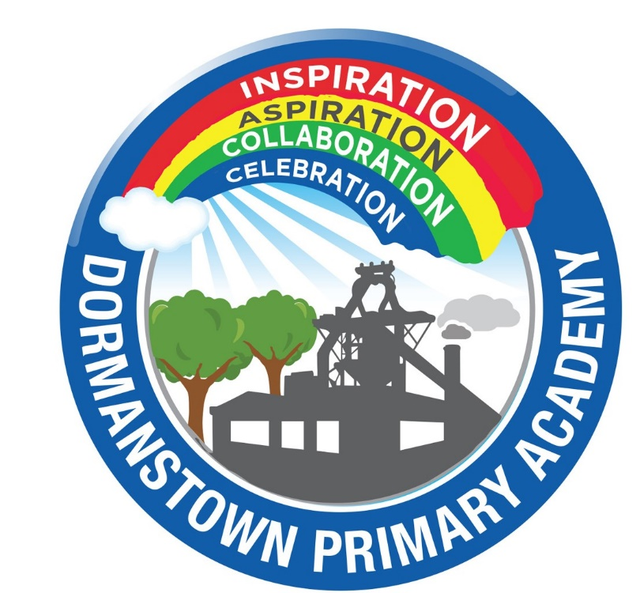
Year 6 / B3A
21/9/20
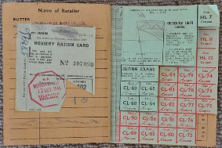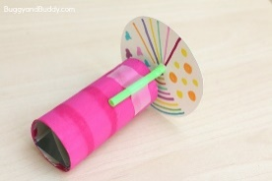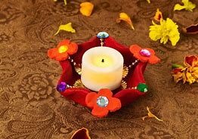
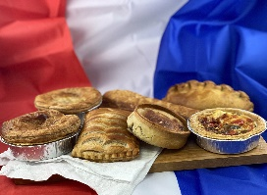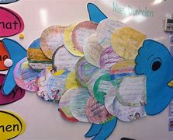
Activity
WB: 28/9 | Create a ration book for a week of eating at home.
WB 5/10 | Can you make a Kaleidoscope?
WB: 12/10 | Make a Diwali candle holder – make sure it’s colourful!
WB: 19/10 | Bake some fresh pastries, sweet or savoury
WB: 26/10 | Create a friendship fish- each scale representing one of your friends.
Hand in date: 20.10.19
Thank you for your continued support.
Miss Anderson, Miss Hill and Mr Stammers

